



NCI Enterprise Security Program

Concept of Operations

For Internal Use Only
September 23, 2009
V.7.0

Table of Content
I. Document History 2

II. Distribution List 2

III. Purpose and Scope 3

IV. Mission 4

V. Objectives 6

VI. Security Program Overview 8

V. Management of NCI-CBIIT Enterprise Security Program 11

VII. Additional Stakeholders 12

Document History

Version | Date | Comments
V.1.0 | March 26, 2009 | First draft
V.2.0 | April 23, 2009 | Content review
V.3.0 | July 29, 2009 | Content review
V.4.0 | August 05, 2009 | Content review
V.5.0 | August 21, 2009 | Content review
V.6.0 | September 18, 2009 | Content review
V.7.0 | September 23, 2009 | Final review

Distribution List

Stakeholder | Title | Interest/Stake
Ken Buetow | CBIIT Director | Sponsor
George A. Komatsoulis (acting) | CBIIT CIO/NCI | Owner
George A. Komatsoulis | CBIIT Deputy Director | Contributor
Dwayne Forquer | CBIIT Chief of Staff/NCI | Advisory
Wendy Patterson | CBIIT CLO/NCI | Contributor
Charlie Mead | CBIIT CTO/NCI/BAH | Contributor
Caterina Lasome | CBIIT COO/NCI
Marsha Young | caBIG Security Policy Project Manager/BAH | Contributor
Avinash Shanbhag | CBIIT Director Engineering | Advisory
Eric Williams | NCI/CBIIT Infrastructure Manager | Advisory
Bruce Woodcock | NCI/CBIIT ISSO | Advisory
Braulio J. Cabral | NCI/CBIIT ESP Coordinator | Contributor
NIH community | NIH | Users
NCI Community | NCI | Users
CBIIT/caBIG Community | CBIIT/caBIG | Users

Purpose and Scope

The main purpose of the NCI Enterprise Security Program (NCI ESP) is to protect the NCI enterprise assets from threats to confidentiality, integrity, and availability. Any item of value to the organization is considered an asset, including; data, information exchanged through or stored in NCI-hosted systems and applications, some of which are considered protected health information (PHI), personally identifiable information (PII), and intellectual property rights, as well as the supporting infrastructure. The goal of the NCI ESP is to protect these assets while facilitating ease of access to data and services for authorized individuals. The NCI ESP implements federal policies, procedures and guidelines for the NCI and its hosted systems and provides guidance concerning security requirements to developers of caBIG® applications and services. The NCI Center for Biomedical Informatics and Information Technology (CBIIT) has program responsibility for the NCI ESP.

The scope of the security program is to coordinate all security related-activities across the NCI enterprise leading to the goal of protecting confidentiality, integrity and availability for NCI-hosted systems and data. Among the activities to be coordinated are: development and implementation of security policies, guidelines, and standards; establishment of processes and procedures to implement policies; and promoting security awareness for all stakeholders. The program covers any system subject to NCI control or location within the enterprise where assets are accessed.

From an enterprise perspective this includes systems hosted by NCI and its contractors, such as caGrid core infrastructure and services, and NCI physical information infrastructure (LAN, servers, data storage, etc.).

Successful operation of the NCI ESP requires the participation of NCI internal and external entities and organizations and the proper identification of roles and responsibilities related to the security program. The distributed nature of NCI staff makes communication and coordination imperative to the success of the program. Another key element in the successful implementation of the program is a well-defined security framework that guarantees the planning, execution and validation of the following topics.

Compliance, privacy, risks assessment, assets classification and ownership, physical and environmental security, business continuity and disaster recovery, network security, access control, authentication, Encryption/key management, segregation of duties, Auditing/logging/monitoring/review software security, incident response, change management, system development life cycle and security awareness.

Mission

The mission of the NCI Enterprise Security Program is to ensure that the full lifecycle and breadth of a robust security program functions well to serve the NCI community of federal system managers and users. The systems covered by the ESP include NCI-hosted applications and databases, NCI-hosted infrastructures such as the caGrid infrastructure.

This mission will be accomplished through a unified security framework that includes the coordination of all NCI IT activities related to security resulting in a “trust fabric” that facilitates secure data management and secure sharing for NCI hosted applications and data as well as for the NCI hosted cancer Grid (caGrid) services, applications and data managed by CBIIT for other components of NCI and other CBIIT applications, and between various Grids, networks and exchanges managed by other entities. The “trust fabric” includes:

- The overarching security policies that govern NCI infrastructure including but not limited to the policies governing the caGrid core infrastructure services, the policies and procedures governing the users of the caGrid core infrastructure services, and the policies and procedures governing all NCI-hosted applications, services and data and the users of those capabilities.
- The operational programs that maintain the internal and external agreements and memoranda of understanding/agreement with other entities outside of CBIIT.
- Guidelines and standards to validate compliance with the policies and technical implementation of the “trust fabric”, as well as compliance with relevant statutes and rules governing federal and non-federal information systems.
- The caGrid security services infrastructure that implements the policies and the operational procedures that govern development, deployment and use of the security services infrastructure.

- The development of a security infrastructure that supports the “trust fabric” described above across all NCI applications.

At a fundamental level, the purpose of this program is to ensure compliance with all applicable federal policies and guidelines with a balance between technology, policy and implementation to ensure that all three of these activities are working toward a common goal The NCI ESP promotes a synergy between policy, engineering, technology and compliance.

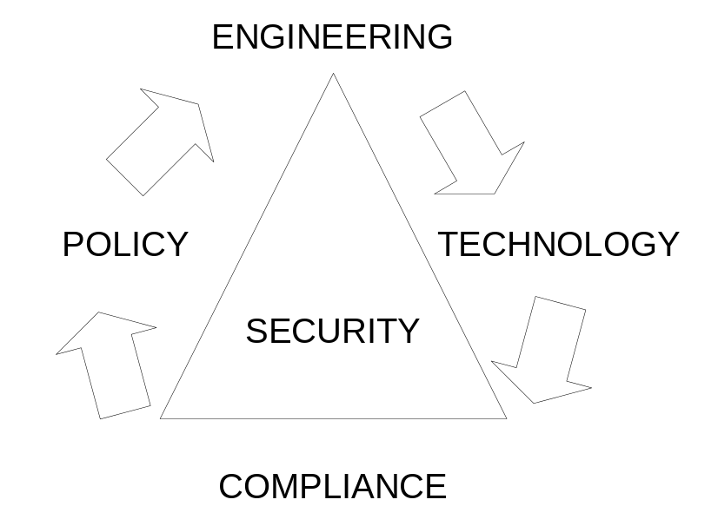

The success of this mission requires the active participation of all stakeholders, the understanding of the different roles and responsibilities for each stakeholder and the willingness to work together for a common cause. Stakeholders include;

- Executive Management Team (CTEAM) which includes; Director COO, CTO, CIO, and CLO and the Chief of Staff.
- Engineering team including; Director of software engineering, Director software architecture, Director Quality Control, Director software deployment
- Infrastructure Engineering and Operations team responsible for implementing and enforcing the security polices pertaining to; network operations, software maintenance, validations and access control, deployment, and change management
- caGrid Administration team. Responsible for the operational management of the various agreements between the NCI and external parties that memorialize commitments to various aspects of the ESP including such documents as Memoranda of Agreement, caGrid node Host agreements, NCI web services use agreements, inter NIH agreements, etc.
- Office of the Chief Information Officer. Responsible for developing and implementing the NCI enterprise wide security policies and procedures including those related to the implementation of FISMA in accord with HHS and NIH umbrella security programs.
- Enterprise Security Program Coordinator, responsible for the overall coordination of the security program among all teams across the NCI and across the full life cycle of the ESP from policy development through the development of security services that implement the policies and procedures and the implementation and compliance of those services.

Objectives

From a business perspective, the Enterprise Security Program is required to adhere to the following guiding principles:

- Compliance: The program must enable compliance with Federal security mandates for those elements of the enterprise services that are hosted by NCI-CBIIT and it must facilitate compliance by users of the services and applications with applicable federal, state and local laws, regulations, policies and other requirements.

- Federation: The infrastructure must allow the secure sharing of identity information between trusted participants and federation of authorization decisions by local data stewards.

- Scalability: The infrastructure must be capable of scaling up to an “arbitrary” number of users and services with minimal disruptive redesign of the infrastructure.

- Clarity: The implementation of the infrastructure must provide understandable guidance to ensure that providers of data understand the necessary level of protection appropriate for various types of data.

- Ease of entry: The infrastructure must provide the minimum barrier to entry for data sharing commensurate with the sensitivity of the information that is being shared and enable appropriate secured access controls.

It is recognized that these guiding principles may at times need to balance against each other.

The Enterprise Security Program Framework encompasses the creation, organization, and execution of four subsidiary objectives that support the overarching objectives of the program:

- Implement security policies inherited from NIH Information Security Plan and create a policy framework that includes any requirements not covered by the NIH ISP.

The policies provide the rules that govern the infrastructure development and implementation to allow and encourage entities to exchange information via a trusted security infrastructure. This framework must allow for the creation of a trust fabric that does not require specific point-to-point trust agreements, but rather is capable of offering a set of mutual trust agreements.

This objective is addressed below in Section VII (Security Program Overview – Security Policy and Compliance.

Create a technical infrastructure that includes the guidelines, standards and procedures, to implement and enforce the policy framework.

This objective is addressed in Section V (Security Program Overview. Security Processes and Procedures.

Define a set of best practices and other enabling processes that will allow individual providers of data services to implement the technical infrastructure in a way that is consistent with the policy framework. This objective is addressed below in Section V (Security Program Overview.

Develop and disseminate informational materials to convey security policies, provide user templates and checklists, explain automated and non-automated (i.e., executed off-line) agreements in use and educate NCI users and other stakeholders interested in understanding the security policies and infrastructure elements of the Enterprise Security Program. This objective is addressed below in Section VII (Security Program Overview - Security Outreach and Awareness
- Finally, the Security Program looks to implement these procedures across NCI and validate compliance. This objective is addressed below in Section VII (Security Program Overview –

To accomplish this mission, it is necessary to follow a well-defined framework that will serve as the overall guidance of the Security Program. NCI ESP can be divided into two main areas, infrastructure and systems security and applications security. The infrastructure and systems security includes NCI network infrastructure, hardware and operating systems, caGrid core services and physical security. The applications security aspect of the program includes the incorporation of functional and non-functional security policies throughout the software development life cycle (SDLC) and the validation of security compliance.

As an institute under NIH, NCI must follow the security policies, standards and guidance established in the NIH Enterprise Information Security Plan (EISP). The NCI security program implements NIH policies and incorporates any security policies that are specific to the systems, applications and services provided by NCI.

Security Program Overview

The NCI Enterprise Security Program is designed to integrate and coordinate all information system security related activities. The entire program will be coordinated by an Enterprise Security Program (ESP) Coordinator, who will report directly to the CBIIT Director and will be accountable to CBIIT leadership for developing integrated project plans, monitoring execution of planned tasks and ensuring that the security infrastructure supports CBIIT security program objectives. As discussed in more detail below in Section X (Management of CBIIT Enterprise Security Program), the ESP Coordinator will work closely with a number of individuals and groups that have various responsibilities for the elements and tasks including in the ESP umbrella program.

The NCI Enterprise Security Program includes:

  - Security Policy
    - Development of procedures and standards for effective implementation of NIH Information Security Plan.

    - Implementation of security policies specifically related to NCI services and operations

    - Development of business level security policies related to CBIIT and caGrid services, service providers and users.
    - Development contract/trust agreements for caGrid users

  - Security Engineering and Operations
    - Determines security models in terms of privacy, confidentiality, integrity and availability
    - Incorporate security policies into the software development life cycle (SDLC)
    - Help in the design, development and implementation security guidance, and standards to help with policy implementation and validation.

  - Security Outreach and Awareness
    - Establish NCI Web Security Presence
    - Strategic Communications from Program Office/CIO/ISSO
    - Development of security awareness material including and outreach sessions.

- Security Policy

The scope of the security policy is limited to NCI’s compliance with Federal information security requirements for NCI-hosted services. The policy framework for the NCI Enterprise Security Program includes the NCI implementation of NIH security policies as well as the development of the security policy elements of the caBIG Data Sharing and Security Framework (DSSF).

The following task areas are included in the security policy part of the NCI ESP:

Development of the security policies framework applicable to all NCI services, applications including but not limited to caGrid core security services including:
- caGrid Trust Agreements, contracts or agreements with Credential Providers where needed

- Identity and Privilege Management policies (Authentication and Authorization Policies)

The security policy activities will be articulated in the following four major documents that flow from the NIH and HHS policies:

- NIH Enterprise Information Security Plan – Describes NIH security controls, tasks and responsibilities, inherited and institutes and centers specific security policies. The NIH Enterprise Information Security Plan is the overarching security policy guide for the NCI Enterprise Security Policy.

- NCI Enterprise Security Policy - Describes federal policies and procedures that flow from the unified set of federal laws, regulations and policies that govern the provision and use of CBIIT supported NCI infrastructure and services, including federally managed systems and all users of those systems.

- caBIG Security Policy Statement for caGrid (the “Thin Book”) – Describes the NIH, NCI and federal-wide policies that govern the provision and use of the caGrid infrastructure specifically for users of the caGrid infrastructure. Serves as the outward facing description of the NCI IT security policy for users of caGrid.

- caBIG Security Policy for caGrid Handbook and Toolkit (or the “Thick Book”), an implementation guidance document that provides further detail to the caGrid policies and that functions as a “how to” manual for caGrid service providers and users.

- Security Engineering and Operations

This group of tasks focuses on developing, implementing and deploying the security infrastructure as informed by the security policies. Specific task areas initially defined include:

- Security Monitoring & Audit Model
- Certification and Accreditation Program Management at the infrastructure (network) level, systems and applications level.
- Compliance Assessment
- Configuration Management and Control
- Contingency planning including:

  - Business impact analysis
  - Business Continuity plan
  - Disaster Recovery plan
  - Security Bridge notification plan
  - Plan maintenance

- Outreach and Awareness of Security Program

These tasks focus on developing materials to inform and guide NCI and caBIG participants and the users and other stakeholders of security services. These tasks also include working closely with the Documentation and Training Workspace and with the DSIC and caGrid Knowledge Centers to develop and disseminate materials and to conduct proactive outreach to the caBIG community to mentor participants in using and understanding the materials and the caGrid infrastructure security services. Specific task areas initially defined include:

- Strategic Outreach and Awareness plan, including:

  - Establish NCI/caGrid Web Security Presence
  - Strategic Communications from Program Office/CIO/ISSO
  - Security Awareness and Outreach Sessions
  - Compliance/Trust Agreement Notifications & Reminders

The following diagram describes how security controls apply to the different components in the NCI ESP security model and who is responsible for the implementation and enforcement of the security policies. The arrows in the diagram represent the security policy flow/inheritance through the components.

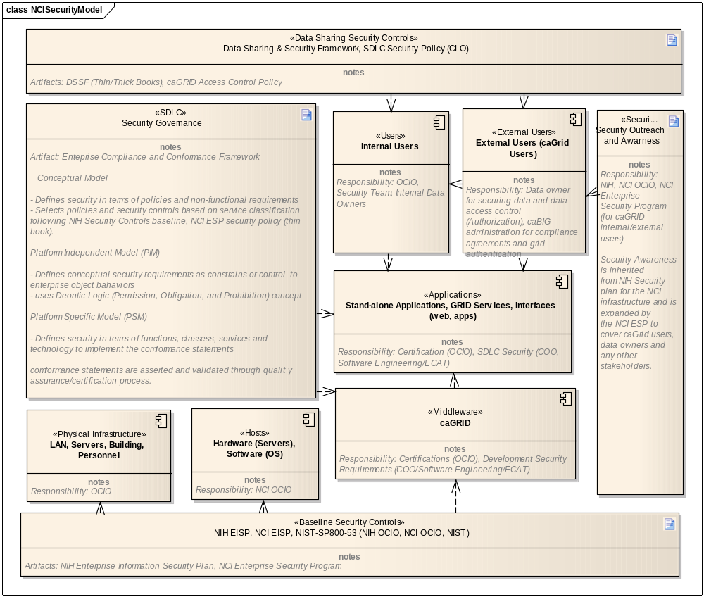
NCI Information Security Controls Model

V. Management of NCI-CBIIT Enterprise Security Program
To plan and coordinate the execution of the security program, the Enterprise Security Program (ESP) has been organized under the ESP Coordinator who will provide the continuity required.

The ESP Coordinator reports to the CBIIT Director and works closely with a number of individuals and groups that have various responsibilities for the elements and tasks included in the ESP program and its umbrella program the NIH EISP.

The members of the integrated team include:

- Chief Information Officer (CIO). The CIO serves as both the CIO for NCI and for CBIIT. As such, the CIO is responsible for implementing federally mandated security policies for all NCI systems and for ensuring compliance with those policies.
NCI CIO is also responsible to the NIH CIO on matters of information security as stated by NIH Security Plan.

The federated nature of the caGrid infrastructure creates some unique requirements for the caBIG program but its security policies must align with those articulated by the NCI (and NIH, HHS) through its CIO. The CIO is also formally responsible for C&A activities on all NCI hosted systems, including the production instance(s) of all caBIG security services.

- Chief Operating Officer (COO). The COO is responsible for the development, implementation and operations of the caGrid infrastructure, including the GAARDS framework and the eventual operations of the caBIG trust fabric.

- Chief Legal Officer (CLO). The CLO is responsible in for caBIG/caGrid security policy development and oversight. The CLO interprets Federal rules that govern privacy and security (and other Federal mandates) and assists numerous others in ensuring compliance with applicable rules, including the Chief Information Officer, who has overall responsibility for the security program across the NCI hosted Federal systems particularly compliance with the Federal Information Security Management Act (FISMA), Privacy Act and FDA Regulations as appropriate to each system.

- NCI Facilitator for the caBIG DSIC Workspace. Currently the CLO also functions in this role. The DSIC WS Facilitator has responsibility within CBIIT for developing the Data Sharing and Security Framework (DSSF) for caBIG/caGrid. The DSSF is a set of “tools” that facilitate addressing obstacles to data sharing such a regulatory, ethical, proprietary or sponsored research obstacles. The DSSF also includes policy and guidance tools, including the security and privacy policies governing the caGrid, some of which are being developed under this program.

- Chief Technology Officer (CTO). The CTO is responsible for overseeing the design of the caBIG Enterprise Architecture and for developing and managing the governance processes that guide its implementation. The CTO chairs the Enterprise Composite Architecture Team (ECAT) that provides architectural oversight, including conformance and compliance oversight and guidance to the development teams.

- Enterprise Composite Architecture Team (E-CAT). The E-CAT advises the “C Team” of CBIIT leadership on technical issues.

- CBIIT Core Infrastructure Staff. The core infrastructure staff is responsible for the design and development of caGrid enterprise services and for developing operational support and guidance materials for entities hosting caGrid nodes and users of caGrid services.

Additional Stakeholders

NCI Chief X Officers: The NCI C Team, listed individually above, is critical to the success of the ESP. Team members individually and collectively share responsibilities for the elements of the full security program for NCI and for caGrid. NCI CBIIT hosts and operates the core infrastructure services of caGrid and is a part of the NIH and HHS, so policies and implementation approaches must be coordinated not only within CBIIT but must align with other security programs. Department of Health and Human Services: The Department has authority in the area of rules development and interpretation of capstone policies, specifically, HIPAA (both the Privacy Rule and the Security Rule), HHS Common Rule as well as security implementing procedures in HHS’ Secure One program and in HHS’ implementing guidance for the Privacy Act and other mandates. Note too that the FDA, as part of HHS, issues regulations that cover the conduct of clinical trials of most devices and drugs.

Office of the National Coordinator for Health IT (ONC): ONC is charged with coordinating health IT infrastructure across the federal government, as well as creating a Nationwide Health Information Network (NHIN). As caGrid has established connectivity to the test NHIN infrastructure, the caBIG security program may serve to inform the NHIN program as a model in some respects.

National Institute of Standards and Technology (NIST): NIST is charged with providing standards for federal information technology systems under the Federal Information Security Management Act (FISMA) of 2002. NIST has also developed standards focused on Role-Based Access Control (RBAC) that will inform any authorization service developed for caGrid.

caBIG User Community: This community includes the direct users of caGrid’s data and analytical services, the stakeholders in and outside of the users’ institutions who have an interest in securing access to health information including patients, and those participating in the evolving BIG Health Consortium™. These are the “customers” or clients of caGrid services, including security services whose trust in the integrity of the controls in and around the services is essential in order to leverage the promise of the caBIG and BIG Health visions to enable collaborative research and the vision of personalized medicine.

caBIG Workspaces: For purposes of describing stakeholders, the community is represented both directly and also by the virtual Workspaces into which the caBIG community is organized. Two key workspaces for purposes of the security program include the Data Sharing and Intellectual Capital Workspace (DSIC) and the Architectural Workspace though the domain workspaces for the Clinical Sciences and the Life Sciences represent the application users and developers of application requirements. Supporting all of the workspaces and the community at large are the Knowledge Centers. For security-related interests, the two key KC stakeholders are the DSIC KC and the caGrid KC. They are charged respectively with mentoring and support to the community respectively in security policy and caGrid technical implementation issues.

Health Level 7 (HL7): ANSI-certified standards development organization (SDO) active in the area of health data standards.

Other standards development organizations (SDOs): The NCI Enterprise Security Program will examine and leverage the work of other standards in place today or emerging as they apply to the security construct areas. There may be emerging standards in the clinical research area emanating from the recently formed ANSI Clinical Research – Electronic Health Records workgroup or from the HHS ONC activities related to the NHIN that will be examined for applicability as they become available.

